Ask Me About  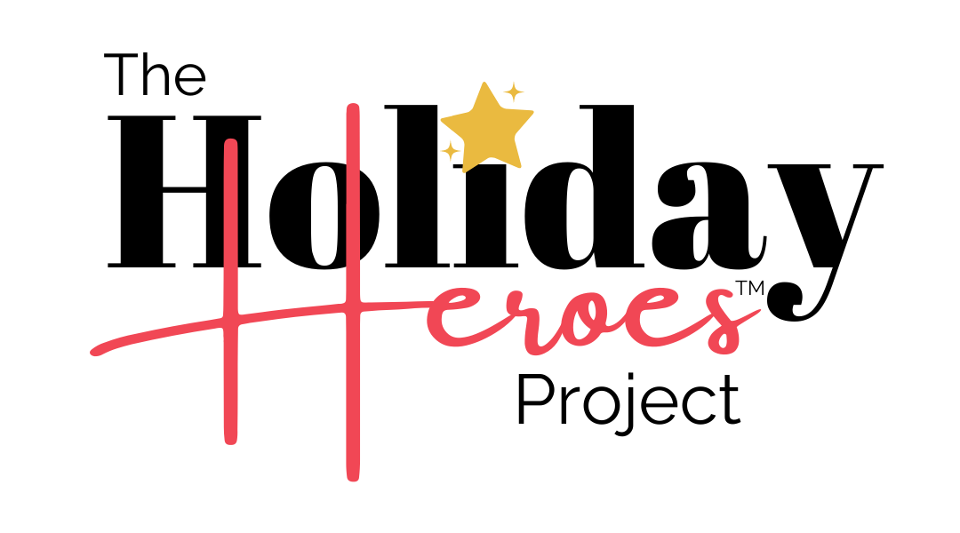 |  | Ask Me About |  | Ask Me About
Ask Me About |  | Ask Me About |  | Ask Me About
Ask Me About |  | Ask Me About |  | Ask Me About
Ask Me About |  | Ask Me About |  | Ask Me About

